


Productive Families Economic Empowerment Programme (DEEP)

DEEP Women Entrepreneurs Project

Progress Report

31st of August, 2014

“Reporting Period: 1st January, 2014 – 30th June, 2014”

Executed by the Productive Families Economic Empowerment Programme (DEEP) – UNDP/PAPP

List of Acronyms

BDS | Business Development Services
CEFE | Competency based Economies, Formation of Enterprises
DEEP | The Productive families Economic Empowerment Programme
DEEP-WE | DEEP Women Entrepreneurs Project
MoA | Ministry of Agriculture
MoSA | Ministry of Social Work
NGO | Non-Government Organization
SEC | Small Enterprises Center
Sida | Swedish International Development Cooperation Agency
SLA | Sustainable Livelihoods Approach

Summary Sheet
- Commencement Date: Jan.1st, 2013. Closing Date: Dec. 31st, 2015
- Total Grant Amount – Sida Contribution: (US$6,000,000)
- Project Scheme: This project aims to graduate, low productive income women who live in vulnerable areas (Area C, East Jerusalem & Gaza), from poverty and aid dependency to being economic self-reliant through income generating activities mainly micro and small enterprises development.
- Expected Period of the Project: 3 years (36 months)
- Implementing Agencies: UNDP/PAPP in partnership with the Ministry of Social Affairs (MoSA), micro-finance institutions, civil society organizations, and the private sector.
- Date of the report: August 31st, 2014

Executive Summary

DEEP Women Entrepreneurs (DEEP-WE) project is targeting women headed families in Area C, East Jerusalem and Gaza Strip. It aims to enable targeted poor, yet productive women to access the needed financial and technical resources to establish their business.

This is a semiannual report covers the period from 1st January, 2014 until 30th June, 2014, which highlights the activities conducted under DEEP-WE project and shed light on women economic opportunities in terms of potentials and challenges. Also the report highlighted the business process of DEEP-WE ranging from women headed families targeting, analysis, training and design of business plans, basic management training for women on how to manage their businesses, procurement of the goods and equipment and continuous follow up.

In this reporting period, 253 poor households started their businesses by 12 partner NGOs, in C areas, East Jerusalem & Gaza Strip. In total, 318 Business plans were prepared either through individual coaching or through joint training for 342 potential beneficiaries. Out of the 318, 253 businesses were already established and 65 businesses are under procurement and about to be delivered to the beneficiaries within 2 months.

General Situation

General Economic Context

Since 2007, increased pressure stemming from the Israeli occupation has negatively affected the wellbeing of the Palestinian economy and the sustainability of community livelihoods. This is mainly demonstrated by the 5 years blockade imposed on the Gaza Strip, the severe access and development restrictions in areas classified "C" and East Jerusalem, and the mobility constraints between the urban centers of the West Bank, which increased poverty especially among women and youth. The above described policy imposed major costs on the Palestinian productive and trade sectors and significantly undercutting development prospects.
In 2008, poverty in the oPt reached up to 57.2% (45.7% in the West Bank, and 79.4% in Gaza Strip). Absolute poverty soared from 20.3% in 1998 to 34.5% in 2007, and the prevalence of extreme poverty increased from 12% in 1998 to 23.8%. Approximately 1.1 million people are currently receiving food aid from humanitarian organizations, primarily by the United Nations Work and Relief Agency (UNWRA) and the World Food Program (WFP). In addition, the labor force statistics published in 2011 show a low participation rate of 41.1%, meaning that less than half of the active population is in the labor market. Of this group, 23.7% are unemployed. The data also indicate that among the 230,000 households that live below the poverty line in the Palestinian occupied territories, approximately 65% have sufficient human and productive capitals to operate profitable economic activities, and if given the appropriate level of business development services and access to finance, these families can achieve successful and sustainable graduation from poverty.
In regards to women employment, the threat on human security imposed by the occupation makes it more difficult for women than men to move between the occupied territories to do business and perform trade related activities. In addition, it limits women physical access to banks and business partners, which further restrict women’s control over various productive assets outside of their immediate vicinity.
The unemployment rate among women with 13 or more years of schooling is 28.8 percent (PCBS, 2008). At 46 percent, unemployment rate of young women between the ages of 20-24 is the highest rate among all age groups, men and women (PCBS, 2008). Competition among women for jobs in the service sector is intense, and jobs go almost exclusively to those with higher education. Even then, educated women’s unemployment rate is very high, especially among young women between the ages of 20 and 24. Women also face family reservations to working outside the home or outside their immediate surroundings because of social and security constraints imposed on their mobility. Similarly, women’s decision making role in the public domain is limited. In 2005, women held 10% of the Director General positions and 5% of the Parliamentary seats.
The primary constraints to women’s entrepreneurship in the West Bank and Gaza Strip are access to finance, cultural attitudes and market access. Women entrepreneurs are largely dependent on the support of husbands or male relatives in the form of finance, advice and encouragement to start up and run their businesses. Among existing women owned businesses marketing their products and services remains a pressing issue.

Women-owned enterprises are growing in number at all levels but continue to remain a minority of all enterprises. According to the ILO, women often turn to starting their own business on account of economic necessity and lack of employment opportunities. In 2006, 5.4 per cent of all enterprises in West Bank and Gaza were women-owned and 26 per cent of micro and small enterprises (six employees or less) (PCBS, 2007). In general women-owned businesses are small scale, although a few own larger businesses. The types of businesses operated by women vary according to locality. Home-based businesses are more common in rural areas than in refugee camps or urban areas.
A World Bank report has highlighted the effect of economic deterioration on female employment, the report shows that many women were forced to work in low skilled labour and unprotected work, while some had to turn to informal activities mainly agriculture, petty trade, and crafts such as sewing and embroidery. The most affected group are the women who head their families where usually their income was insufficient to compensate for the income loss of the former bread-winner in the family.
This increasing poverty has meant that there are fewer resources for women. Usually, the most affected members of the families are the girls, who find less chance to continue education and a greater possibility to get married in an early age, because most families would redirect their income towards food consumption and family survival, and much less will be allocated towards education of their daughters/sisters. Although, very little data is available on the cost of higher education and the link with household poverty, the only estimates available indicate that household expenditure on education varies enormously. The poorest households with a total consumption of less than US$284 per month spend only US$10 per annum on education while the richer households with monthly consumption of more than US$1,400 spend over 80 times this amount. This clearly indicates that access to higher education varies by household income, leading, in consequence, to the marginalization of female students from poorer families who cannot afford the high tuition and education fees.
As noted, Palestinian women have been specifically affected by the conditions impacting on the lives of Palestinians. The situation is compounded by decreased investments from the private sector and the increased burden on the already stretched public sector. Private investments dropped by over 15% between 2005 and 2006 with no significant increase traced in 2007, and private sector productivity have been progressively replaced by public spending and sustained donor funding. As a result of the above conditions, unemployment figures rocketed with around 26% of Palestinians no longer engaged in active job search in 2008, and only modest changes in average women employment levels have occurred.

Overview about DEEP-WE

The DEEP-Women Entrepreneurs is a project that promotes inclusive economic growth; it is a specialized economic empowerment project that helps productive low income women graduate from poverty and aid dependency and become economic self-reliant. DEEP-Women is based on the results chain already adopted in the Deprived Economic Empowerment Programme (DEEP). The DEEP modality provides a solid and inclusive approach for targeting vulnerable, yet productive, households and engaging their members in sustainable income generating activities, mainly micro and small enterprise development, to provide employment and bridge their consumption poverty gap.
The model has been tested with 7,000 new individual and group enterprises in 323 communities in the West Bank, Gaza, and Jerusalem between the years 2006 - 2011. According to the outcome evaluation, conducted by the Islamic Development Bank and the Palestinian Authority for the first three years, 85% of the established enterprises were operational and gradually closing on the household poverty gap after three years of startup date. 28% of the established enterprises grow and have completely closed the poverty gap; and have provided employment for other households as a result. The DEEP programme has succeeded in its first phase to help 12,000 youth, women and people with disability become active participants in economic growth after being, for years, beneficiaries of social welfare programs.
More specifically, DEEP-Women aims to assist low income women and their households to graduate from poverty through establishing income generation projects. The project will work on identifying relevant and feasible activities to be implemented with women through qualified and experienced NGOs, business development service providers, and microfinance institutions. The project adopts a participatory methodology in the design of income generating interventions that builds on and develops the exiting capitals that define the household's livelihoods. Through this methodology, the project ensures that the targeted women are actively engaged in the process of the design and implementation, thereby ensuring a strong sense of ownership among them which is a guarantee of the sustainability of the intervention.
DEEP-Women Entrepreneurs will provide business development services and coaching to 772 entrepreneurs including training and on site consultancy, it will offer solidarity financing to 772 entrepreneurs to assist in the procurement of the goods, works or services as necessary inputs for their economic projects. Moreover, this programme will develop a distinct branding for the support of Sweden to women's economic employment in Area C, East Jerusalem and Gaza.

Program Components

The table below shows the progress that aims at achieving the expected outcome: “Targeted Palestinian women entrepreneurs belonging to low income families from Gaza, Area C and East Jerusalem can access needed financial and technical resources to start their businesses, and adopt positive and sustainable livelihoods strategies”, the program includes the below two outputs:
Outcome: Targeted Palestinian women entrepreneurs belonging to low income families from Gaza, Area C and East Jerusalem become economically empowered by accessing needed financial and technical resources to start their businesses, and adopt positive and sustainable livelihoods strategies.
SMART Indicators | Results | Results
SMART Indicators | year 2  (Expected) | year 2  (Actual)
% of interventions that were financed and still operational after 6 months | 80% | 100%
# of unpaid jobs created (average of 2 household members work in the project as unpaid) (253*2) | 436 | 506
# of paid jobs created ((average of 1 household members work in the project as paid) (253*1) | 126 | 253
% of households stopped depending on cash transfers (Cash transfer won’t be stopped before 2 years of establishing the business) | 70% | 0%
Bridging Objective: Capacity of program implementing partners for poverty reduction strengthened
SMART Indicators | Results | Results
SMART Indicators | year 2  (Expected) | year 2  (Actual)
# of staff who received at least one training course | 16 | 16
% of beneficiaries’ assessments that rejected by PMU | <10% | 6%
% of project ideas as a result of household assessment analysis. | 80% | 65%
Satisfaction of beneficiaries about their performance | 85% | 85%
% of closed projects due to faulty process | 0 | 0
Activities
- Identify the capacity building areas based on capacity partners assessment (Done)
- Select and contract the training providers (Done)
- Conduct a series of training courses and coaching activities to partners’ staff (Done)

EXPECTED OUTPUTS |  | PLANNED ACTIVITIES (Status)
Output 1:  Business development service packages was delivered |  | Select and contract the BDS provider (Done)
 |  | Review all the materials, coaching methodologies and training related issues (Done)
 |  | Conduct training on ToT, ToC and on poverty for BDS providers (Done)
 |  | Prepare a set of business plans for business start-ups (Done)
 |  | Conduct a set of business plan training courses (Done)
 |  | Conduct a set of field visits to beneficiaries’ businesses for coaching, supporting and mentoring (Done)
SMART Indicators (This report covers the period from 1st of January - until 30th of June, 2014/ 6 months) |  |  |  | Result  2nd Year  (Expected) | Result  2nd Year (Actual)
- # of training courses  - # of trainees  - % of trainees are satisfied  - # of business plans that were developed during the training  - % of business plans that were developed regard to # of beneficiaries that attend the training  - % of beneficiaries that attend all training days  - # of beneficiaries that received at least one coaching session  - The average # of field visits that were conducted per beneficiary to deliver coaching services. |  |  |  | 17  386  80%  386  95%  85%  386  3 | 9  244  88%  203  83%  95%  84  1
Target status during reporting period | Launching of the beneficiaries training on business planning and development was delayed for 2 months, as the Small Enterprises Center (SEC), needed longer time to arrange for the training in 9 NGOs in the same time. This caused a consequent delay on preparing and finalizing the business plans, before launching the procurement process.
Output (2):  Targeted women have access to finance to establish or develop their own business. |  |  | Prepare the nominees lists. (Since January, the partner NGOs started adopting the community targeting approach instead of receiving nominees list from MoSA) (Done)
 |  |  | Select and contract the qualified partners based on their strength and geographic distribution of nominees (Done)
 |  |  | Conduct a capacity building package for selected partners (Done)
 |  |  | Conduct an assessment of 1016 nominees based on sustainable livelihood approach (Done)
 |  |  | Processing business places and purchase goods, tools and equipment based on business plans. (On-going)
SMART Indicators (This report covers the activities from 1st of January until 30th of June, 2014) |  |  |  | Result  2nd Year  (Expected) | Result  2nd Year  (Actual)
- % of financed projects were start-up (new) projects  - # of business that established(start-up)  - # of businesses are existed are developed |  |  |  | 90%  386  39 | 97%  248  5
Target status during reporting period | 10 NGOs were contracted to implement 2014 scope of work, in addition to those “3 NGOs” contracted in 2013, this followed by hiring the required staff members. Later, the NGOs staff members attended training courses on community and entrepreneurship approached targeting, and then contributed to developing DEEP WE procedure manual. The targeted and selected beneficiaries based on SLA attended 12 days training courses, in order to be able to prepare their projects business plans. The procurement process won’t be covered under this report as it was launched in most of the NGOs in July, 2014.  The 6 months of 2014 witnessed a progressive and intensive work from the partner NGOs, where they received training on the entrepreneurship targeting associated with community targeting approaches, followed by the training on business planning and development. Then, the formulation of community committees were launched, who contributed to the selection and targeting of the beneficiaries, followed by analyzing the beneficiaries situation and nominating them for the training on business planning and development.

Implementation Modality for Grants Component

As stated above, 10 additional partner NGOs were approached to check their interest in working with DEEP WE, and since those NGOs used to work on DEEP IDB agreement, there was no need to conduct capacity assessment for those NGOs. The 10 NGOs were requested to submit filled applications including work plan and budget for the agreed upon number of beneficiaries in specific targeted areas. For 2014, the 10 NGOs that were contracted to carry out the intended activities DEEP WE are the following;
# | NGO | Governorate
1 | Qader for Community Development | Hebron & Jerusalem Governorate
2 | Ma’an Development Center | Jerusalem (West Bank)
3 | Palestinian Youth Union (PYU) | Jerusalem Governorate
4 | Annajdeh Palestinian Women’s Development Society (NAJDEH-WB) | Jerusalem Governorate & Ramallah
5 | Mother School Society (MSS) | Nablus
6 | Arab Center for Agricultural Development (ACAD) | Nablus
7 | Juhoud for Community and Rural Development (Juhoud) | Salfeet
8 | Palestinian Agricultural Relief Committees (PARC) | East Jerusalem
9 | Gaza Culture and Development Group (GCDG) | Gaza Strip
10 | Job Creation Programme | Gaza Strip

In 2013, 3 NGOS were contracted under DEEP WE
# | NGO | Governorate
1 | The Palestinian Business Women’s Association (ASALA) | Bethlehem & Gaza Strip
2 | Palestinian Agricultural Relief Committees (PARC) | Jerusalem Governorate
3 | MA’AN Development Center for area C - Jordan Valley (MA’AN) | Jordan Valley (Tubas, Jericho & Nablus)

It’s worth to be mentioned that the above 3 mentioned NGOs, which were contracted in 2013 continued working in 2014.

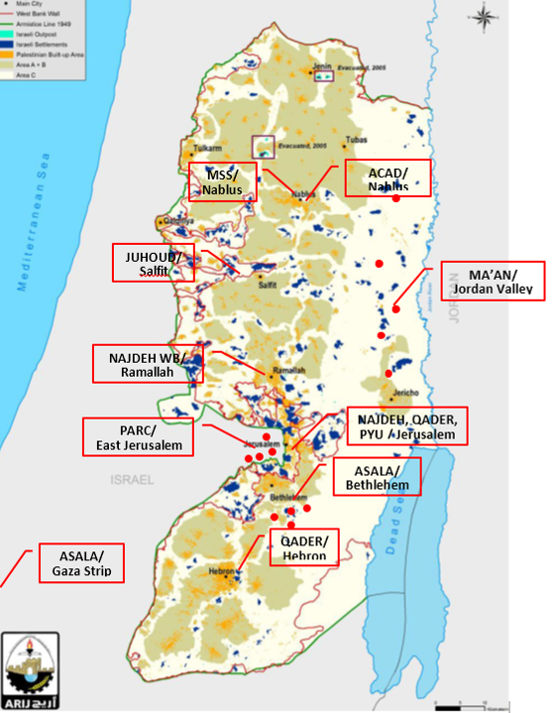

The above-mentioned NGOs used to carry out the activities ranging from families’ targeting and analysis, training of beneficiaries on business planning and development, in addition to finalizing of business plans “carried out by Small Enterprises Center SEC” and followed by procurement of goods.
The diagram below exhibits the above mentioned process which is implemented in the grant component:
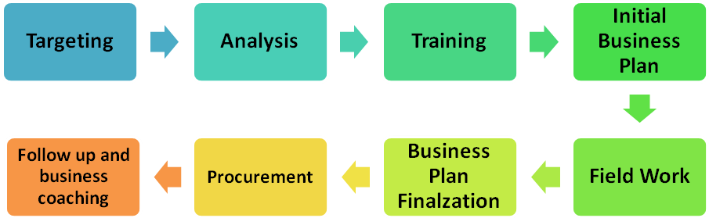

Business Process

Utilizing the accumulated experience in DEEP, the business process for the program was designed in order to choose the best candidates for this program on one hand and to ensure the best service delivery to the chosen beneficiaries on the other. The main stages of this process are:
- Targeting: in which households are visited by field staff and filtered through the selection criteria of the program (belonging to one of the three marginalized groups)
- Analysis: Analysis for the households is conducted using the Sustainable Livelihoods Approach (SLA) in order to identify their capacities and assets that can be built on in order to develop a positive sustainable livelihood strategy.
Items number 1 and 2 are under the responsibility of the NGO
- Design which includes Training and Business Plan Preparation: During this phase the beneficiaries receive training for 12 comprehensive training on business skills and in the same time a sound business plan is developed for their business ideas. This task is mainly managed by SEC.
- Procurement and Business Establishment: After the business plans are developed the implementing partners start procuring the assets and goods needed to establish the businesses for the beneficiaries in compliance with UNDP’s financial rules and regulation. This task is carried out by the NGOs.
- Follow up and Coaching: In order to ensure that the beneficiaries are running their businesses in the best manner, and to ensure the sustainability of the businesses, follow up and business coaching will be conducted to help beneficiaries deal with the various issues they face in marketing, production, finance, etc.. This task will be jointly managed by MoSA Field workers, NGOs and SEC

The diagram below shows the business process:-

Involved party | Stage | Input / output | Used toos | Duration
Partner NGO's | Perform the Need Assessment (S.L.A)  ` | Names list of needy families  Description of the family resources & Business ideas |  | 2 months
Small Enterprise Center (SEC) | Business idea Analysis and feasibility check |  | Business Model | 1 weeks  (2 sessions)
Small Enterprise Center (SEC) | Idea is feasible  Change business idea  No  Yes
Small Enterprise Center (SEC) | Preparing full Business plans | Business plans for the approved ideas | SEC BP template | 2 weeks  (3 sessions)
Small Enterprise Center (SEC) | Training on business management skills | Trained business entrepreneurs on the basic marketing, management, and financial skills | CEFE method | 1 week
Partner NGO's | Procurement | Established Businesses  Approved Business plans |  | 1 month
SEC | Business advising and follow up | Follow up report / Recommendations |  | 5 months-  Regular visits (5 sessions per business)

Implementation Modality for Microfinance:
Map Source: ARIJ

There are seven Microfinance institutions that are qualified to work with DEEP, one institution “Palestine for Credit and Development-FATEN” is contracted to empower the Women in Gaza strip. The MFI starts targeting the existing and the start up enterprises that are owned by the poor families and managed by women in Gaza strip. An agreement with REEF Finance Co. is under preparation and will include the empowerment of Women through microfinance in East Jerusalem. A negotiation is lunched with another MFIs to target women in Area C in the West Bank.

Program Achievements

395 female beneficiaries distributed in East Jerusalem, C Areas and Gaza Strip, will benefit from DEEP-WE services in the in 2014, through access to finance to establish or develop their business start-ups. The targeted beneficiaries were distributed among the below NGOs and Governorates as illustrated in the below table;

DEEP-WE Scope of Work (2014)
# | NGO | Locality | Targeted Households/ Locality | Scope of Work | Governorate
1 | Qader for Community Development (QADER) | Edhna | 8 | 50 | Hebron
1 | Qader for Community Development (QADER) | Assamou | 6 | 50 | Hebron
1 | Qader for Community Development (QADER) | Al-Sawahra Asharqeieh | 6 | 50 | Jerusalem (West Bank)
1 | Qader for Community Development (QADER) | Abu Dees | 10 | 50 | Jerusalem (West Bank)
1 | Qader for Community Development (QADER) | Al’Azariyah | 10 | 50 | Jerusalem (West Bank)
1 | Qader for Community Development (QADER) | Aza’iyem | 5 | 50 | Jerusalem (West Bank)
1 | Qader for Community Development (QADER) | Ash-Sheikh Sa’ad | 5 | 50 | Jerusalem (West Bank)
2 | Ma’an Development Center (MA’AN) | Beit Anan | 6 | 15 | Jerusalem (West Bank)
2 | Ma’an Development Center (MA’AN) | Beit Surik | 6 | 15 | Jerusalem (West Bank)
2 | Ma’an Development Center (MA’AN) | Beddo | 8 | 15 | Jerusalem (West Bank)
2 | Ma’an Development Center (MA’AN) | Al-Qbeiba | 6 | 15 | Jerusalem (West Bank)
2 | Ma’an Development Center (MA’AN) | Beit Doqqo | 5 | 15 | Jerusalem (West Bank)
2 | Ma’an Development Center (MA’AN) | Beit Ijza | 3 | 15 | Jerusalem (West Bank)
2 | Ma’an Development Center (MA’AN) | Qatanna | 8 | 15 | Jerusalem (West Bank)
2 | Ma’an Development Center (MA’AN) | Beit Iksa | 5 | 15 | Jerusalem (West Bank)
2 | Ma’an Development Center (MA’AN) | Al-Nabi Samoeil | 3 | 15 | Jerusalem (West Bank)
3 | Palestinian Youth Union (PYU) | Bir Nabala | 8 | 35 | Jerusalem (West Bank)
3 | Palestinian Youth Union (PYU) | Qalandia Al Balad | 5 | 35 | Jerusalem (West Bank)
3 | Palestinian Youth Union (PYU) | Beit Hanina Al Balad | 5 | 35 | Jerusalem (West Bank)
3 | Palestinian Youth Union (PYU) | Al-Jdireh | 5 | 35 | Jerusalem (West Bank)
3 | Palestinian Youth Union (PYU) | Al-Jeeb | 6 | 35 | Jerusalem (West Bank)
3 | Palestinian Youth Union (PYU) | Rafat | 6 | 35 | Jerusalem (West Bank)
4 | Annajdeh Palestinian Women’s Development Society (NAJDEH-WB) | talfeet | 9 | 35 | Jerusalem (West Bank)
4 | Annajdeh Palestinian Women’s Development Society (NAJDEH-WB) | Jaba’a | 6 | 35 | Jerusalem (West Bank)
4 | Annajdeh Palestinian Women’s Development Society (NAJDEH-WB) | Hizma | 6 | 35 | Jerusalem (West Bank)
4 | Annajdeh Palestinian Women’s Development Society (NAJDEH-WB) | Deir Abu Masha'l | 4 | 35 | Ramallah
4 | Annajdeh Palestinian Women’s Development Society (NAJDEH-WB) | Al-Liban Algharbi | 5 | 35 | Ramallah
4 | Annajdeh Palestinian Women’s Development Society (NAJDEH-WB) | Deir Qaddis | 5 | 35 | Ramallah
5 | Mother School Society (MSS) | Qusra | 5 | 25 | Nablus
5 | Mother School Society (MSS) | Talfeet | 5 | 25 | Nablus
5 | Mother School Society (MSS) | Qariout | 5 | 25 | Nablus
5 | Mother School Society (MSS) | Jaloud | 5 | 25 | Nablus
5 | Mother School Society (MSS) | Joreesh | 5 | 25 | Nablus
6 | Arab Center for Agricultural Development (ACAD) | Burqa | 5 | 85 | Nablus
6 | Arab Center for Agricultural Development (ACAD) | Annaqura | 5 | 85 | Nablus
6 | Arab Center for Agricultural Development (ACAD) | Ijnesenia | 5 | 85 | Nablus
6 | Arab Center for Agricultural Development (ACAD) | Jamaeen | 5 | 85 | Nablus
6 | Arab Center for Agricultural Development (ACAD) | Oreef | 5 | 85 | Nablus
6 | Arab Center for Agricultural Development (ACAD) | Awarta | 5 | 85 | Nablus
6 | Arab Center for Agricultural Development (ACAD) | Einabous | 5 | 85 | Nablus
7 | Juhoud for Community and Rural Development | Deir Ballout | 5 | 25 | Salfeet
7 | Juhoud for Community and Rural Development | Kefel Hares | 5 | 25 | Salfeet
7 | Juhoud for Community and Rural Development | Hares | 5 | 25 | Salfeet
7 | Juhoud for Community and Rural Development | Broqeen | 5 | 25 | Salfeet
7 | Juhoud for Community and Rural Development | Marda | 5 | 25 | Salfeet
Scope of Work_2014_ West Bank |  |  |  | 270
8 | Palestinian Agricultural Relief Committees (PARC) | Silwan | ---- | 50 | East Jerusalem
8 | Palestinian Agricultural Relief Committees (PARC) | Athoari | ---- | 50 | East Jerusalem
8 | Palestinian Agricultural Relief Committees (PARC) | Old City | ---- | 50 | East Jerusalem
8 | Palestinian Agricultural Relief Committees (PARC) | Im Tuba | ---- | 50 | East Jerusalem
8 | Palestinian Agricultural Relief Committees (PARC) | Alaisawieh | ---- | 50 | East Jerusalem
Scope of Work_2014_ East Jerusalem |  |  |  | 55
9 | Gaza Culture and Development Group (GCDG) | Entire Gaza Strip |  | 35 | Gaza Strip
10 | Job Creation Programme (JCP) | Entire Gaza Strip |  | 35 | Gaza Strip
Scope of Work_2014_ Gaza Strip |  |  |  | 70
Total Scope of Work for 2014 |  |  |  | 395

DEEP-WE Scope of Work (2013)
# | NGOs | Area C “West Bank” | East Jerusalem | Gaza Strip | Total | Governorate
1 | PARC | - | 45 | - | 45 | East Jerusalem
2 | MAAN | 105 | - | - | 105 | Jericho/ Tubas
3 | ASALA | 55 | - | 50 | 105 | Bethlehem/ Gaza
Total |  | 160 | 45 | 50 | 255
Total Scope of Work for 2013 |  |  |  |  | 255

Projects Outputs

Output #1: Business development service packages are delivered

→ (In 2014, 267 potential female beneficiaries were exposed to either individual coaching or joint entrepreneurs’ training, in order get trained on business planning principles and requirements. As a result to those training and coaching sessions, 213 business plans were ready in order for the entrepreneurs to launch their start-ups.
The coaching sessions and training courses that were conducted from 1st January, 2014 until 30th June, 2014 are illustrated below;
Training courses (individual coaching sessions)
NGO | # of Trainees | # of finally selected entrepreneurs | # of submitted business plans
MA’AN | 25 | 21 | 21
ASALA | 24 | 18 | 18
PARC | 63 | 45 | 45
Total | 112 | 84 | 84

In order to develop the above business plans, the business advisors carried out 300 individual coaching sessions and 52 follow up sessions after the startups are existed.
Training courses (Joint Training Courses)
NGO | # of Trainees | # of finally selected entrepreneurs | # of submitted business plans
PYU | 20 | 17 | 17
NAJDEH-WB | 18 | 16 | 16
QADER – Abu Dees | 18 | 16 | 16
QADER – Alaizarieh | 17 | 12 | 12
ASALA– Wadi Fokeen | 19 | 18 | 18
MSS – Qusra | 18 | 15 | 15
MSS – Talfeet | 13 | 10 | 10
MA’AN – Azbeidat | 17 | 13 | 13
MA’AN – Ein Shibli | 15 | 12 | 12
Total | 155 | 129 | 129

The Business advisors carried out 129 individual coaching sessions to verify the developed business plans with entrepreneurs.

Achieved Activities:
- 3 days training to the business advisors (18 business advisors) on the customization of CEFE to be used with the women entrepreneurs during the business-planning phase.
- 3 days training workshop to the business advisors (18 business advisors) on business diagnosis.

Output #2: Targeted Women have access to finance to establish or develop their own businesses
→ This output is dependent on the progress taking place in output 1 mentioned above, especially in providing economic empowerment grant. The targeted women once they enter into the business planning & development phase, the most appropriate model for each one of them will be determined, whether providing grants or micro-finance, in order to ensure relevant and effective access to the necessary resources needed to build and operate the project; therefore, the beneficiaries who received the assets through grants until 30th of June, 2014 were 253 businesses
NGO | Scope of Work (until the end of 2014 | The families who were nominated for the project by community | The families who were analyzed through SLA | The # of Business Plans | The # of delivered projects
QADER | 50 | 252 | 190 | 28 | 28 under procurement
MA’AN | 120 | 247 | 247 | 68 | 48 Delivered & 20 under procurement
PYU | 35 | 230 | 41 | 17 | 16 under procurement
NAJDEH WB | 35 | 60 | 40 | 16 | 16 under procurement
MSS | 25 | 89 | 25 | 25 | 25 Under procurement process
ACAD | 85 | 123 | 44 | Under preparation | 0
JUHOUD | 25 | 159 | 42 | Under preparation | 0
PARC | 100 | 188 | 110 | 45 | 45
ASALA | 105 | 231 | 132 | 89 | 55
GCDG | 35 | 87 | 67 | 14 | 0
JCP | 35 | 96 | 78 | 16 | 0
Total | 650 | 1762 | 1016 | 318 | 253

Achieved Activities:
- Activities in the Economic Empowerment Grants
- Assets Provision & Delivery: DEEP Team attended the projects/ assets delivery for the beneficiaries under NGOs contracts from 2013, in order to ensure compatibility between bill of quantities in the business plans and actual provided assets. In addition, DEEP team provided the required support and technical advices for the beneficiaries through business advisors and project coordinators.
- Bookkeeping, marketing & production training: Organizing 3 days’ training workshop on Bookkeeping, marketing and production for beneficiaries of 3 NGOs.
- Follow up visits: DEEP Team continuously organize field visits for the startups to check on the status of businesses, daily performance in terms of financial revenues and growth and impact on families’ socio-economic situation.
- Training on agricultural and animal production projects: This training was organized for one day for the beneficiaries who have agricultural and animal enterprises, such as greenhouses, poultry, goats and cows.
- NGOs selection for 2014: In addition to the 3 existing partner NGOs, The project initiated meetings with 6 NGOs, to explore their interest and capacity to work on DEEP WE. Later, those NGOs were requested to submit filled applications, which include detailed work plan and budgets for the scope of work to be achieved in 2014. The submitted and filled applications were reviewed thoroughly and discussed with each NGO, until all agreed on all the items, which were followed by signing the agreements among the two parties.
- Training on Entrepreneurs Selection & Poverty Analysis: Organizing 3 days’ training workshop for the 9 partner NGOs, which aimed to develop a procedures manual for DEEP-WE. This workshop was attended by 26 staff members from the partner NGOs; mainly the project coordinators and field workers. In that workshop, the concept and history of entrepreneurship was explained and the agreed upon criteria for selecting and choosing the female entrepreneurs were defined among all the participants. Moreover, the business planning process was introduced to the participants, moving from exploring idea until coaching and mentoring of beneficiaries. The 2nd and 3rd days of the training witnessed mechanisms of household’s’ poverty analysis and targeting and selecting of beneficiaries through community leaders.
- DEEP-WE Operational Manual: DEEP Team in cooperation with DEEP consultant and based on inputs from the above mentioned workshop, managed to develop DEEP WE procedures manual.
- Integrating project within MOSA Strategy: For this purpose, DEEP is still supporting MOSA with 21 Field Workers over all West Bank districts who are following up and supervising the fieldwork on daily bases. In addition to their main task in targeting women headed families and providing the adequate advice and support on the established businesses.
- Coaching for Partner NGOs on the targeting and analysis stages for households: DEEP Team conducted 10 coaching sessions to the NGOs working on DEEP-WE, to ensure that those NGOs or well adopting the procedure’s manual in all the work process phases.
- Networking and Coordination with Community Members: In all the targeted localities, the Partner NGOs conducted several meetings and discussions with local and village councils, CBOs and CSOs. The NGOs explained the DEEP We objectives, work process, criteria to choose female entrepreneurs and the required cooperation from the local community, such as the need to formulate a committee from the active community members, who will be able to nominate female poor entrepreneurs. Later, a committee was formulated to nominate female poor entrepreneurs based on a set up and agreed upon criteria, which includes; motivated, active, self-confident and poor.
- Screening of the nominated households by the committees: 1762 households were nominated by the committed for the NGOs for potential economic empowerment. Those households were requested to fill applications which assess their need and interest in DEEP-WE, and after submitting their applications the NGOs staff conducted desk review for the applications.
- Analysis of households: out of the targeted 1762 households, 1016 were analyzed through assessment and analysis for all the capitals and resources of the families Sustainable Livelihood Approach (SLA) (physical, human, natural, social & financial capitals) in addition to entrepreneurship spirits.

- Training on business planning and development: these 342 females who proved to have entrepreneurships spirits and poor, attended 12 comprehensive days on Competency Based Economies, Formation of Enterprises (CEFE) where they got the opportunity to be trained on management, production, marketing and got hands-on experience of preparing their own business plans.

- Business plans Finalization: Those entrepreneurs who showed high commitment of attending all the training days and good capability of learning and searching on the market details, stepped on a further step through finalizing their business plans by their business advisors.

- Follow up on NGOs Performance: DEEP Team continuously provide the technical advice to the partner NGOs either through periodic meetings, phone calls and exchanged e-mails, in addition to sudden visits and following up DEEP MIS as part of the monitoring process.

- Procurement of Goods: 329 business plans were provided to the NGOs in charge, to proceed in finalizing the bill of quantities and request for quotations and/ or tendering. 237 Female entrepreneurs received their grant “assets” until the date of this project as illustrated in the above table.

- Providing Micro financing Services
- Micro-Loans:
Faten started to target women headed families in Gaza strip, about 40 loan applications were filled, reviewed and financially assessed. The procurement of goods and assets were started for other Women enterprises. Some of the targeted Women are searching for the guarantors and others are waited to provide the proper needed documentations before the financing started on the ground. The financing process is completed for 25 Women. The average loan size is expected to decrease in Gaza, and by that, the number of expected beneficiaries is expected to increase as a result. However, the average loan size will be higher in the West Bank, and Jerusalem.

Challenges & Obstacles

- Definition of the word “entrepreneur” under DEEP WE, does not take the same definition as the international definition “The person who develops his own business model and takes the risk on the success and failure of the project and has the right path of his future business”. Instead, the entrepreneur was commonly defined with most of the partner NGOs and a sample of people in C areas, as the active, motivated and has the ability to search for the information, but doesn’t have to know all the aspects of her future project target, as DEEP WE combines between both entrepreneurship and poverty in C areas.

- Finding out and access to female entrepreneurs through community leaders “committees” is taking longer time than MoSA families, yet more productive and effective. The process of formulating committees and/ or opening the door for applications from women entrepreneurs, led to a delay in the targeting stage, which in turn caused for a shift in some project activities, in addition to imposing more load & pressure on the project coordinators and field workers in the partner NGOs.

- The involvement of two parties “SEC and the NGO” in one business process, caused a dilemma in the accountability, causes and reasons behind the delay of the project activities. Such that the training courses for beneficiaries on business planning by SEC, development of business plans by the female entrepreneurs and finalization of business plans by SEC, used to take 6 weeks at least. This used to be followed by submitting the final business plans to the NGOs, where the later “NGO” sometimes needed additional 10 days to modify and edit some parts of the bill of quantities based on the actual and available items in the market.

- A notable number of households changed their project ideas after the assessment analysis, which was a result of Absence of Vocational Assessment in the targeting stage, as most of the field workers experiences are in social work.

- Reaching out to women in C areas and East Jerusalem was very difficult due to the geographic expanded areas and lack of public transportation in most of those areas, which called for more efforts and time from the team to finish their duties.

- Since C areas are located in small and scattered villages with a relatively small number of population, the possibility of diversification and feasibility of enterprises in those areas is questionable. This leads to traditional projects ideas with less guaranteed sustainability.

- The majority of people who live in C areas are poor and few of them are either middle class or rich, this affects the purchase power parity and the potential for success.

- Women roles in C areas are still controlled by cultural, traditional and social features, as these communities are mainly rural and/ or Bedouin. These kinds of communities, male dominant communities, do not provide women with leadership and decision making roles. Such that, many of the targeted and nominated female entrepreneurs changed their projects ideas under pressure from their male relatives; fathers, brothers or husbands in order to establish businesses for their male relatives not for the females themselves. Those entrepreneurs who insisted to establish male type projects were at the end excluded from the business planning process.

- In some of the targeted localities especially in the small-scale localities, the NGOs teams could not establish a committee from the local community since the population in those villages are all relatives and from one family. In order to ensure transparency in those localities, public announcements were hanged in the public and well-known places, which called for submitting applications for entrepreneurship economic empowerment. This action led to receiving large number of applications which need thorough and long process of reviewing the applications.

- Lack of the female beneficiary of the specific and exact requirements for her enterprise led to a delay in the work process and greater efforts from both SEC and the NGO team.

- The procurement process for some businesses that include variety of products, such as; accessories shops, groceries and clothes shops, requires longer time during specifying the goods, which needs at least 5- 7 visits for similar shops to identify and specify the required and exact items.

- Procurement of livestock and goats is very complicated, due to the preconditions and blood tests imposed by MoA for all the goats, which takes unguaranteed time because of the kits needed, not to mention the unavailability of those kits for 2 months sometimes and the long duration required for the results. The earlier mentioned complexities of tests were sudden and out of picture for all the parties involved in purchasing goats as the process was paralyzed for a remarkable period.

Recommendations

- In order to solve the issue of having two main partners and accountability issue, DEEP Team after several discussions decided to embed the BDS inside the NGO, where 2 BDS advisors to be hired and provide this service including training and verification of business plans. This action will ensure high commitment from one partner NGO, strong and day to day relation, which in turn will contribute to the quality of provided business plans and acceleration of procurement process.

- Some of the female entrepreneurs received coaching sessions for preparing business planning, instead of training on business planning, due to their lack of capacity of preparing their own business plans and/ or their engagement in day to day family and agricultural activities. It was noticed that the females who received training on business planning got the opportunity to be motivated through competition and discussion of different ideas with other female entrepreneurs, enhanced their personal merits and technical skills, which contributed to their sense of ownership towards their enterprises, consequentially this was reflected positively on their enterprises performance from the early stages.

- In order to provide economic empowerment interventions for 35 female entrepreneurs, starting from the targeting until procurement, DEEP team concluded that the required time should not be less than 10 months.

- The importance of arranging periodic meetings for the beneficiaries, for the purpose of sharing and exchange of experiences, issues and problems solving suggestions. This will improve the rural women’s technical skills and social relations, which will be reflected on their enterprises positively.

- The necessity of conducting training courses for the NGOs staff on vocational assessment that might contribute to enhancing the projects ideas compatibility with the targeted women skills and experiences.

- The importance of organizing channels for marketing among entrepreneurs in the same value chain, as marketing aspects is still a concern for most of DEEP WE beneficiaries.

- The necessity of arranging new training courses for DEEP Team and the partner NGOs staff on new methods and tools of entrepreneurship assessment, poverty analysis and business development, in order to improve the entire business process under DEEP WE.

Annex 1: List of the established/ to be established businesses and locations of these businesses

# | Locality | Enterprise | Status
QADER
1 | Abu Dees | Weddings Requirements | Under Procurement
2 | Abu Dees | Sweets Shop | Under Procurement
3 | Abu Dees | Home Textiles Shop | Under Procurement
4 | Abu Dees | Womens Clothes Shop | Under Procurement
5 | Abu Dees | Hijabi Clothes Shop | Under Procurement
6 | Abu Dees | Grocery | Under Procurement
7 | Abu Dees | Bookshop | Under Procurement
8 | Abu Dees | Tailoring Shop | Under Procurement
9 | Abu Dees | Beauty Care Center | Under Procurement
10 | Al'aizariyeh | Kids' Clothes Shop | Under Procurement
11 | Al'aizariyeh | Grocery | Under Procurement
12 | Al'aizariyeh | Cosmetics Shop | Under Procurement
13 | Al'aizariyeh | Hijabi Clothes Shop | Under Procurement
14 | Al'aizariyeh | Kids' Clothes Shop | Under Procurement
15 | Al'aizariyeh | DJ | Under Procurement
16 | Al-Sawahreh Asharqieh | Photography Shop | Under Procurement
17 | Al-Sawahreh Asharqieh | Beauty Salon | Under Procurement
18 | Al-Sawahreh Asharqieh | DJ | Under Procurement
19 | Al-Sawahreh Asharqieh | Home Utensils Shop | Under Procurement
20 | Al-Sawahreh Asharqieh | Clothes Shop | Under Procurement
21 | Al-Sawahreh Asharqieh | Construction Tools Renting | Under Procurement
22 | Ash-Sheikh Sa'ad | Grocery | Under Procurement
23 | Ash-Sheikh Sa'ad | Construction Tools Renting | Under Procurement
24 | Ash-Sheikh Sa'ad | Grocery | Under Procurement
25 | Ash-Sheikh Sa'ad | Sweets Shop | Under Procurement
26 | Ash-Sheikh Sa'ad | Grocery | Under Procurement
27 | Aza’iyem | Womens Clothes Shop | Under Procurement
MA'AN
1 | Al'auja | Grocery | Delivered
2 | Al'auja | Goats breeding | Delivered
3 | Al'auja | Goats breeding | Delivered
4 | Al'auja | Goats breeding | Delivered
5 | Al'auja | Goats breeding | Delivered
6 | Al'auja | Grocery | Delivered
7 | Al'auja | Goats breeding | Delivered
8 | Al'auja | Goats breeding | Delivered
9 | Al'auja | Goats breeding | Delivered
10 | Al'auja | Mobile Phones Selling & Maintenance Shop | Delivered
11 | Al'auja | Goats breeding | Delivered
12 | Al'auja | Goats breeding | Delivered
13 | Al'auja | Green House | Under Procurement
14 | Al'auja | Upgrading of Tailoring Workshop | Under Procurement
15 | Al'auja | Chairs Renting | Under Procurement
16 | Al'auja | Green House | Under Procurement
17 | Al'auja | Green House | Under Procurement
18 | Aljiftlik | Goats breeding | Delivered
19 | Aljiftlik | Goats breeding | Delivered
20 | Aljiftlik | Goats breeding | Delivered
21 | Aljiftlik | Green House | Delivered
22 | Aljiftlik | Goats breeding | Delivered
23 | Aljiftlik | Goats breeding | Delivered
24 | Aljiftlik | Goats breeding | Delivered
25 | Aljiftlik | Goats breeding | Delivered
26 | Aljiftlik | Events Requirements (Chairs/ Tables, etc) | Delivered
27 | Aljiftlik | Green House | Delivered
28 | Aljiftlik | Agricultural Pont | Delivered
29 | Azbeidat | Upgrading of Grocery | Under Procurement
30 | Azbeidat | Accessories Shop | Under Procurement
31 | Azbeidat | Weddings Requirements | Under Procurement
32 | Azbeidat | Kids' Clothes Shop | Delivered
33 | Bardalah | Goats breeding | Delivered
34 | Bardalah | Cows breeding | Delivered
35 | Bardalah | Goats breeding | Delivered
36 | Bardalah | Goats breeding | Delivered
37 | Bardalah | Cows breeding | Delivered
38 | Bardalah | Cows breeding | Delivered
39 | Bardalah | Broiler Chicken breeding | Under Procurement
40 | Bardalah | Green House | Under Procurement
41 | Ein Elbeidah | Goats breeding | Delivered
42 | Ein Elbeidah | Goats breeding | Delivered
43 | Ein Elbeidah | Goats breeding | Delivered
44 | Ein Elbeidah | Green House | Under Procurement
45 | Ein Shibli | Goats breeding | Delivered
46 | Ein Shibli | Goats breeding | Delivered
47 | Ein Shibli | ChickPeas breeding | Under Procurement
48 | Ein Shibli | Goats breeding | Delivered
49 | Fassayel | Goats breeding | Delivered
50 | Fassayel | Goats breeding | Delivered
51 | Fassayel | Goats breeding | Delivered
52 | Fassayel | Goats breeding | Delivered
53 | Fassayel | Goats breeding | Delivered
54 | Fassayel | Goats breeding | Delivered
55 | Fassayel | Goats breeding | Delivered
56 | Fassayel | Goats breeding | Delivered
57 | Fassayel | Goats breeding | Delivered
58 | Fassayel | Goats breeding | Delivered
59 | Fassayel | Upgrading of Beauty Salon | Under Procurement
60 | Froush Beit Dajan | Green House | Under Procurement
61 | Froush Beit Dajan | Green House | Under Procurement
62 | Froush Beit Dajan | Green House | Under Procurement
63 | Kardalah | Green House | Under Procurement
64 | Kardalah | Green House | Under Procurement
65 | Marj Na'ajeh | Beauty Salon | Delivered
66 | Marj Na'ajeh | Goats breeding | Delivered
67 | Marj Na'ajeh | Green House | Under Procurement
68 | Marj Na'ajeh | Tractor for a female Beneficiary | Under Procurement
PARC
1 | Jerusalem/ Old City | Sweets Shop | Delivered
2 | Jerusalem/ Old City | Beauty Salon | Delivered
3 | Jerusalem/ Old City | Pickles Producing | Delivered
4 | Jerusalem/ Old City | Clothes & Cosmetics | Delivered
5 | Jerusalem/ Old City | Tailoring Shop | Delivered
6 | Jerusalem/ Old City | Photoghraphy Shop | Delivered
7 | Jerusalem/ Old City | Icecream & Drinks Shop | Delivered
8 | Al-Thoari | Bookshop | Delivered
9 | Al-Thoari | Grocery | Delivered
10 | Al-Thoari | Beauty "Facial" Salon | Delivered
11 | Al-Thoari | Tailoring Shop | Delivered
12 | Al-Thoari | Weddding Accessories Shop | Delivered
13 | Al-Thoari | Tailoring Shop | Delivered
14 | Al-Thoari | Photography Shop | Delivered
15 | Alaisawieh | Clothes Shop | Delivered
16 | Alaisawieh | Cafeteria | Delivered
17 | Alaisawieh | Clothes Shop | Delivered
18 | Alaisawieh | Accessories Shop | Delivered
19 | Alaisawieh | Dry Clean | Delivered
20 | Alaisawieh | Accessories Shop | Delivered
21 | Alaisawieh | Clothes Shop | Delivered
22 | Alaisawieh | Goats breeding | Delivered
23 | Alaisawieh | Clothes Shop | Delivered
24 | Alaisawieh | Detergents Shop | Delivered
25 | Alaisawieh | Sweets Shop | Delivered
26 | Alaisawieh | Beauty Salon | Delivered
27 | Silwan | Home Accessories | Delivered
28 | Silwan | Detergents Shop | Delivered
29 | Silwan | Photography | Delivered
30 | Silwan | Clothes Shop | Delivered
31 | Silwan | Grocery | Delivered
32 | Silwan | Cosmetics | Delivered
33 | Silwan | Detergents Shop | Delivered
34 | Silwan | Accessories Shop | Delivered
35 | Silwan | Bathrooms Appliances Shop | Delivered
36 | Silwan | Grocery | Delivered
37 | Silwan | Grocery | Delivered
38 | Silwan | Clothes & Cosmetics | Delivered
39 | Silwan | Home Sweets Kitchen | Delivered
40 | Silwan | Advertising Office | Delivered
41 | Silwan | Bridal Gowns Shop | Delivered
42 | Silwan | Home Made Kitchen | Delivered
43 | Silwan | Home Accessories | Delivered
44 | Silwan | Bridal Gowns Renting Shop | Delivered
45 | Silwan | Beauty Salon | Delivered
MSS
1 | Jaloud | Cows breeding | Under Procurement
2 | Jaloud | Grocery | Under Procurement
3 | Jaloud | House Utensils & Staionery Shop | Under Procurement
4 | Jaloud | Poultry breeding | Under Procurement
5 | Qusra | Birds breeding | Under Procurement
6 | Qusra | Poultry breeding | Under Procurement
7 | Qusra | Arabic Bread Bakery | Under Procurement
8 | Qusra | Shiny Drop "Beauty Shop" | Under Procurement
9 | Qusra | Broiler Chicken | Under Procurement
10 | Qusra | Poultry breeding | Under Procurement
11 | Qariout | Grocery | Under Procurement
12 | Qariout | Baladna Bakery | Under Procurement
13 | Qariout | Frozen Food Shop | Under Procurement
14 | Qariout | Grocery | Under Procurement
15 | Qariout | Poultry breeding | Under Procurement
16 | Qariout | Kindergarten | Under Procurement
17 | Qariout | DJ for events | Under Procurement
18 | Talfeet | Cows breeding | Under Procurement
19 | Talfeet | Clothes Shop | Under Procurement
20 | Talfeet | Cosmetics Shop | Under Procurement
21 | Joreesh | Mini Market | Under Procurement
22 | Joreesh | Beauty Salon | Under Procurement
23 | Joreesh | Grocery | Under Procurement
24 | Joreesh | Poultry breeding | Under Procurement
25 | Joreesh | Poultry breeding | Under Procurement
PYU
1 | Al-Jeeb | Mobile Phones Seeling & Maintenance Shop | Under Procurement
2 | Al-Jeeb | Goats breeding | Under Procurement
3 | Al-Jeeb | Bookshop and Gifts | Under Procurement
4 | Al-Jeeb | Frozen Food Shop | Under Procurement
5 | Al-Jeeb | Humus & Falafel Restaurant | Under Procurement
6 | Al-Jeeb | Goats breeding | Under Procurement
7 | Al-Jdireh | Grocery and Vegetables Shop | Under Procurement
8 | Al-Jdireh | Tailoring Shop/ House | Under Procurement
9 | Al-Jdireh | Grocery | Under Procurement
10 | Al-Jdireh | Home Accessories Shop | Under Procurement
11 | Al-Jdireh | Detergents Shop | Under Procurement
12 | Al-Jdireh | Upgrading of Tailoring Shop | Under Procurement
13 | Al-Jdireh | Home Made Kitchen | Under Procurement
14 | Al-Jdireh | Upgrading of Grocery | Under Procurement
15 | Qalandia | Goats breeding | Under Procurement
16 | Qalandia | Goats breeding | Under Procurement
Najdeh WB
1 | Jaba'a | Tailoring Shop | Under Procurement
2 | Jaba'a | Grocery | Under Procurement
3 | Jaba'a | Beauty Salon | Under Procurement
4 | Jaba'a | Spices Shop | Under Procurement
5 | Jaba'a | Embroidery related stuff shop | Under Procurement
6 | Jaba'a | Grocery | Under Procurement
7 | Jaba'a | Poultry breeding | Under Procurement
8 | Anata | Shoes Shop | Under Procurement
9 | Anata | Accessories Shop | Under Procurement
10 | Anata | Childrens' Clothes Shop | Under Procurement
11 | Anata | Frozen Food Shop | Under Procurement
12 | Anata | Womens' Clothes Shop | Under Procurement
13 | Anata | Hijabi Clothes Shop | Under Procurement
14 | Hizma | House Utensils Shop | Under Procurement
15 | Hizma | Clothes Shop | Under Procurement
16 | Hizma | Clothes Shop | Under Procurement
17 | Hizma | House Utensils & Gifts Shop | Under Procurement
18 | Hizma | Tailoring Shop | Under Procurement
19 | Hizma | Cosmetics and Accessories Shop | Under Procurement
20 | Al-Liban Algharbi | Nursery | Under Procurement
21 | Al-Liban Algharbi | Electric Appliances Shop | Under Procurement
22 | Al-Liban Algharbi | Beauty Salon | Under Procurement
23 | Al-Liban Algharbi | House Utensils Shop | Under Procurement
24 | Deir Qadees | Grocery | Under Procurement
25 | Deir Qadees | Green House | Under Procurement
26 | Deir Qadees | Broiler Chicken | Under Procurement
27 | Deir Qadees | Green House | Under Procurement
28 | Deir Qadees | Beauty Salon | Under Procurement
29 | Deir Abu Masha'l | Upgrading of Grocery | Under Procurement
30 | Deir Abu Masha'l | Frozen Food Shop | Under Procurement
31 | Deir Abu Masha'l | Beauty Salon | Under Procurement
32 | Deir Abu Masha'l | Home Bakery & Kitchen | Under Procurement
33 | Deir Abu Masha'l | Beauty Tools Shop | Under Procurement
34 | Deir Abu Masha'l | Poultry breeding | Under Procurement
35 | Deir Abu Masha'l | Grocery | Under Procurement
ASALA
1 | Alwalajeh | Goats breeding | Delivered
2 | Beit Fajjar | Goats breeding | Delivered
3 | Beit Fajjar | Goats breeding | Delivered
4 | Beit Fajjar | Goats breeding | Delivered
5 | Beit Fajjar | Gym Club for Women | Delivered
6 | Beit Fajjar | Grocery | Delivered
7 | Beit Fajjar | Accessories Shop | Delivered
8 | Beit Fajjar | Home Utensils Shop | Delivered
9 | Beit Fajjar | Goats breeding | Delivered
10 | Beit Fajjar | Accessories Shop | Under Procurement
11 | Marah Rabah | Goats breeding | Under Procurement
12 | Marah Rabah | Goats breeding | Under Procurement
13 | Marah Rabah | Goats breeding | Under Procurement
14 | Marah Rabah | Goats breeding | Delivered
15 | Marah Rabah | Goats breeding | Under Procurement
16 | Marah Rabah | Goats breeding | Under Procurement
17 | Marah Rabah | Goats breeding | Under Procurement
18 | Marah Rabah | Goats breeding | Under Procurement
19 | Marah Rabah | Goats breeding | Under Procurement
20 | Marah Rabah | Goats breeding | Under Procurement
21 | Marah Rabah | Goats breeding | Under Procurement
22 | Marah Rabah | Goats breeding | Under Procurement
23 | Tqou' | Grocery | Delivered
24 | Tqou' | Goats breeding | Delivered
25 | Tqou' | Goats breeding | Delivered
26 | Tqou' | Grocery | Delivered
27 | Tqou' | Goats breeding | Delivered
28 | Tqou' | Goats breeding | Delivered
29 | Tqou' | Goats breeding | Delivered
30 | Tqou' | Goats breeding | Delivered
31 | Tqou' | Grocery | Delivered
32 | Tqou' | General Services Office | Delivered
33 | Tqou' | Home Utensils Shop | Delivered
34 | Wadi Fukin | Green House | Delivered
35 | Wadi Fukin | Green House | Delivered
36 | Wadi Fukin | Green House | Delivered
37 | Wadi Fukin | Poultry breeding | Delivered
38 | Wadi Fukin | Poultry breeding | Under Procurement
39 | Wadi Fukin | Poultry breeding | Under Procurement
40 | Wadi Fukin | Poultry breeding | Under Procurement
41 | Wadi Fukin | Chicken Eggs Incubator | Under Procurement
42 | Wadi Fukin | Poultry breeding | Under Procurement
43 | Wadi Fukin | Gym Club | Under Procurement
44 | Wadi Fukin | Accessories Shop | Under Procurement
45 | Wadi Fukin | Weddings Requirements | Under Procurement
46 | Wadi Fukin | Home Utensils Shop | Under Procurement
47 | Wadi Fukin | Clothes Shop | Under Procurement
48 | Wadi Fukin | Rabbits Breeding | Under Procurement
49 | Wadi Fukin | Electric Appliances Shop | Under Procurement
50 | Wadi Fukin | Green House | Under Procurement
51 | Wadi Fukin | Green House | Under Procurement
52 | Wadi Fukin | Frozen Food Shop | Under Procurement
53 | Wadi Fukin | Beauty Salon | Under Procurement
54 | Wadi Fukin | Green House | Under Procurement
55 | Wadi Fukin | Coffee shop | Under Procurement
56 | East Gaza | Grocery | Delivered
57 | East Gaza | Clothes Shop | Delivered
58 | East Gaza | Commercial Store (2.5 Shekels Store) | Delivered
59 | East Gaza | Clothes Shop & Others | Delivered
60 | East Gaza | Pastries | Delivered
61 | Gaza City | Accessories Shop | Delivered
62 | Gaza City | Beauty Salon | Delivered
63 | Gaza City | Beauty Salon | Delivered
64 | Gaza City | Booksshop | Delivered
65 | Gaza City | Booksshop | Delivered
66 | Gaza City | Grocery | Under Procurement
67 | Gaza City | Grocery and Frozen Food | Under Procurement
68 | Gaza City | Tailoring & Emroidery | Under Procurement
69 | Gaza City | Grocery and Frozen Food | Under Procurement
70 | Khan Younes | Detergents Shop | Delivered
71 | Khan Younes | Grocery | Delivered
72 | Khan Younes | Home Utensils Shop | Under Procurement
73 | Khan Younes | Grocery | Under Procurement
74 | Khan Younes | Grocery | Under Procurement
75 | Khan Younes | Grocery | Under Procurement
76 | Khan Younes | Grocery | Under Procurement
77 | Khan Younes | Wholesaler for Food Supply | Under Procurement
78 | Khan Younes | Booksshop | Under Procurement
79 | Khan Younes | Accessories Shop | Under Procurement
80 | Middle Gaza | Beauty Salon | Delivered
81 | Middle Gaza | Clothes Shop | Delivered
82 | Middle Gaza | Clothes Shop | Delivered
83 | Middle Gaza | Accessories + Perfumes | Delivered
84 | Middle Gaza | Tailoring & Emroidery | Delivered
85 | Middle Gaza | engraving on wood & handicrafts | Delivered
86 | Middle Gaza | Grocery & Fodder | Under Procurement
87 | Middle Gaza | Clothes Shop | Under Procurement
88 | North Gaza | Beauty Salon | Delivered
89 | North Gaza | Tailoring & Emroidery | Delivered
GCDG
1 | Albreij | Birds Breeding | Business Plan is completed
2 | Almughraqa | Birds Breeding & Fodder Selling | Business Plan is completed
3 | Annuseirat | Embridery & tailoring | Business Plan is completed
4 | Annuseirat | Clothes Design & Tailoring | Business Plan is completed
5 | Deir Albalah | Bookshop+ Office Equipment Maintenance | Business Plan is completed
6 | Gaza City | Upgrading of Beauty Salon | Business Plan is completed
7 | Gaza City | Clothes Peddler | Business Plan is completed
8 | Gaza City | Sewing Machine and Clothes Shop | Business Plan is completed
9 | Gaza City | Grocery | Business Plan is completed
10 | Gaza City | Upgrading of Women Tailoring Shop | Business Plan is completed
11 | Gaza City | Bridal Gowns Rental/ Cosmetics Shop | Business Plan is completed
12 | Gaza City | Sluch & smothie Shop | Business Plan is completed
13 | Gaza City | Beauty Salon | Business Plan is completed
14 | Gaza City | Beauty Salon | Business Plan is completed
JCP
1 | Khan Younes | Detergents Shop | Business Plan is completed
2 | Rafah | Broiler breeding | Business Plan is completed
3 | Rafah | Green Housee | Business Plan is completed
4 | Rafah | Pastries & Frozen Food Shop | Business Plan is completed
5 | Rafah | Pigeons Breeding Farm | Business Plan is completed
6 | Rafah | Tailoring Workshop | Business Plan is completed
7 | Rafah | Embroidery & handicrafts Shop | Business Plan is completed
8 | Gaza City | Grocery | Business Plan is completed
9 | Gaza City | Chairs & Pergolas Renting | Business Plan is completed
10 | Gaza City | Upgrading of a bookshop | Business Plan is completed
11 | Gaza City | Embroidery & handicrafts Shop | Business Plan is completed
12 | Gaza City | Grocery | Business Plan is completed
13 | Gaza City | Clothes Shop | Business Plan is completed
14 | Gaza City | Poultry Breeding | Business Plan is completed
15 | Middle Gaza | Electricity Appliances and maintenance Shop | Business Plan is completed
16 | North Gaza | Wholesaler for Food Supply | Business Plan is completed

Annex 2: The Financial Report: Budget Vs. Actual Report for the period, From 1st of January until 30th of June, 2014
The Deprived Families Economic Empowerment Programme - Women Entrepreneurs ( DEEP-WE )
Budget Vs. Actual Report for the period : From Inception till June 30th , 2014
Item | Budget Allocation (1) | Commitments |  | Disbursements | Disbursements | Cumulative Disbursements | Cumulative Disbursements | Remaining Undisbursed Balance | Budget Balance
Item | Budget Allocation (1) | Implementing Partner | Contractual Commitment (2) | As of September 30th 2013 (3) | From October 2013 to December 2013 (4) | From Jaunary 2014 to June 2014 (5) | As of June 30 th 2014 (6= 3+4+5) | (7 = 2 - 6) | Uncommitted funds (1 - 2)
Item | USD | Implementing Partner | USD | USD | USD | USD | USD | USD | USD
Output 1:Business Development | 467,832 | Small Enterprise Center (SEC) | 260,760 | 200,000 | - | - | 200,000 | 60,760 | 172,872
Output 1:Business Development | 467,832 | The Institute European de Cooperation et de Development (IECD) | 34,200 | - | - | 34,200 | 34,200 | - | 172,872
Output 2: Grants | 4,541,730 | Palestinian Agricultural Relief Committees (PARC ) | 1,344,696 | 271,614 | - | - | 271,614 | 1,073,082 | 82,631
Output 2: Grants | 4,541,730 | MA'AN Development Center ( MA'AN ) | 786,223 | 134,841 | - | 356,541 | 491,382 | 294,841 | 82,631
Output 2: Grants | 4,541,730 | Palestinian Business Women's Association (ASALA) | 778,689 | 186,325 | - | - | 186,325 | 592,364 | 82,631
Output 2: Grants | 4,541,730 | Palestinian Youth Union (PYU) | 261,577 | - | - | 30,577 | 30,577 | 231,000 | 82,631
Output 2: Grants | 4,541,730 | QADER for Community Development | 374,869 | - | - | 21,365 | 21,365 | 353,504 | 82,631
Output 2: Grants | 4,541,730 | JUHOUD for Community and Ruler Development(JCRD) | 203,175 | - | - | 31,060 | 31,060 | 172,115 | 82,631
Output 2: Grants | 4,541,730 | Mother's School Society (MSS) | 186,875 | - | - | 21,875 | 21,875 | 165,000 | 82,631
Output 2: Grants | 4,541,730 | ANNAJDEH Palestinian Women's Development Society | 261,353 | - | - | 16,316 | 16,316 | 245,037 | 82,631
Output 2: Grants | 4,541,730 | The Arab Center for Agriculture Development (ACAD) | 261,642 | - | - | 16,533 | 16,533 | 245,109 | 82,631
Capacity Building for MoSA ( to establish links between the project economic intervention and existing social protection & psychosocial services) | 150,000 |  | - | - | - | - | - | - | 150,000
Communication & Transportation | 66,597 | UNDP | 9,250 | - |  | 9,250 | 9,250 | - | 57,347
Staffing | 258,000 | UNDP | 120,642 | 6,481 | 21,859 | 92,303 | 120,642 | (0) | 137,358
Audit, Midterm Review, and Final Evaluation | 75,000 | UNDP | 10,000 | - | - | 10,000 | 10,000 | - | 65,000
Total Implementation Cost (1) | 5,559,159 | - | 4,893,951 | 799,261 | 21,859 | 640,020 | 1,461,139 | 3,432,812 | 2,126,347
GMS (2) | 389,141 |  | 342,577 | 55,948 | 1,530 | 44,801 | 102,280 | 240,297 | 148,844
ISS (3) | 51,700 |  | 45,514 | 501 | - | 684 | 1,185 | 44,329 | 7,371
Total (1+2+3) | 6,000,000 | - | 5,282,042 | 855,710 | 23,389 | 685,505 | 1,564,604 | 3,717,438 | 2,282,562

Annex 3: Photos from the Field
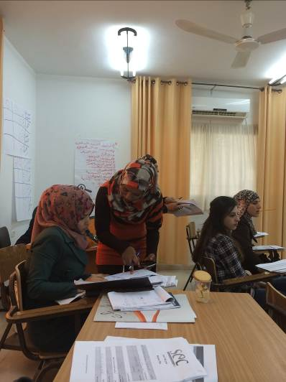
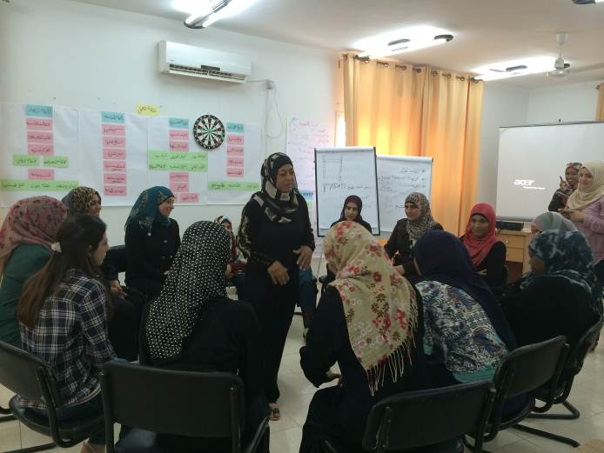
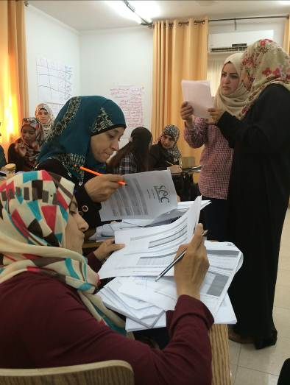
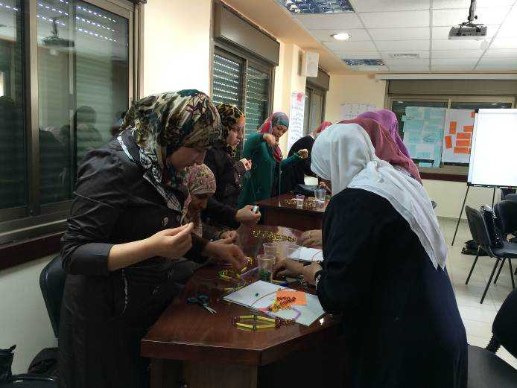
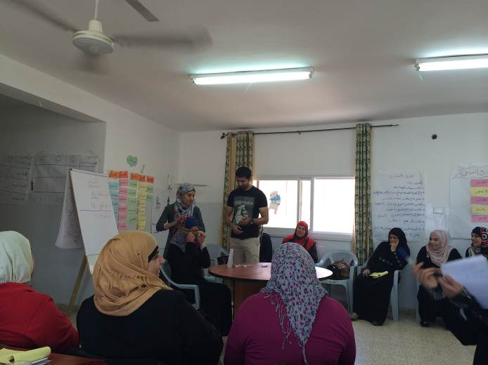
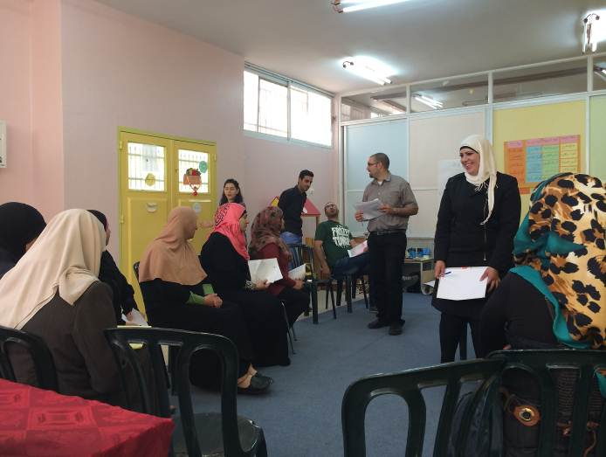
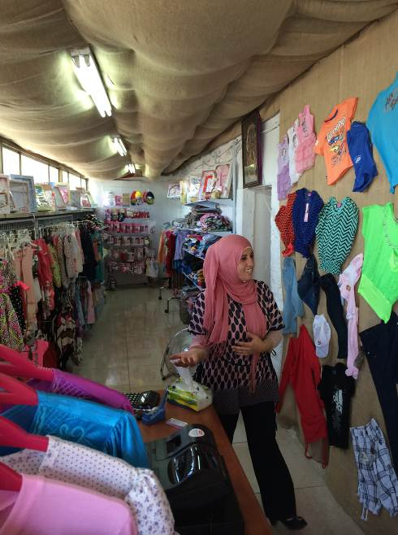
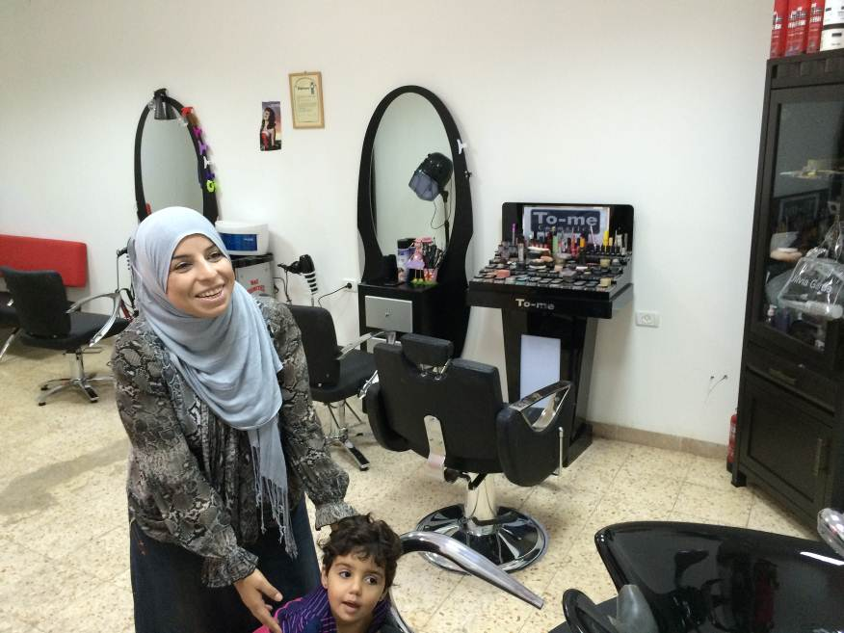
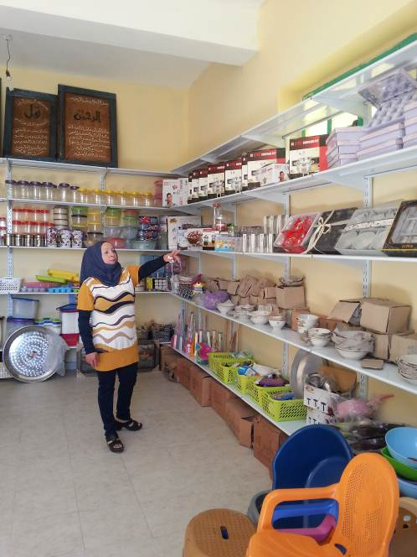
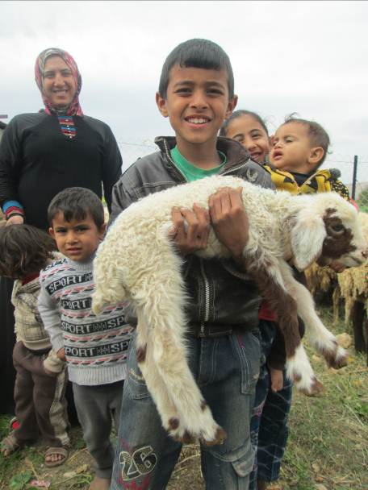
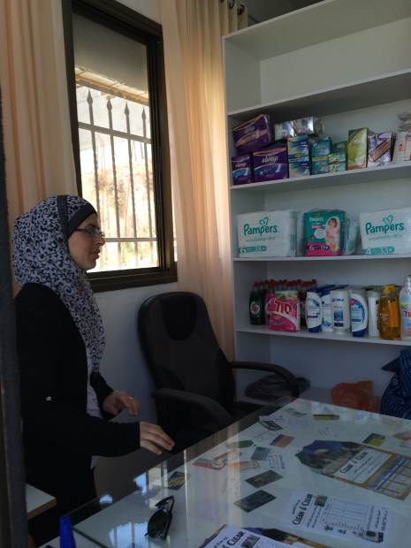
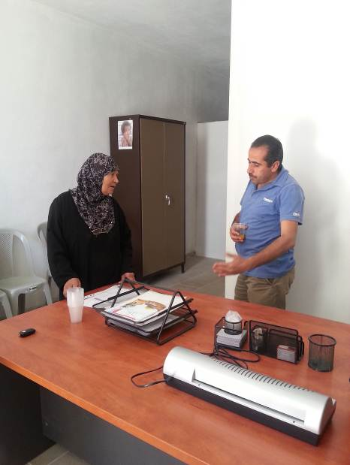
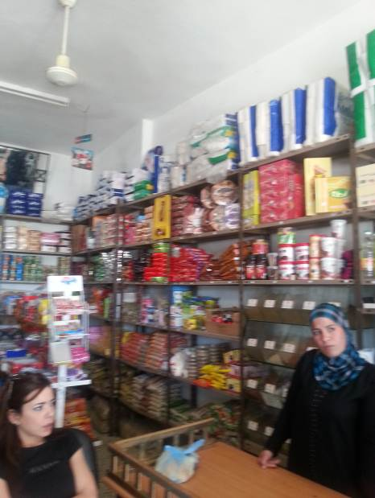

World Bank, West Bank and Gaza, Education Sector Analysis, Impressive Achievements under Harsh Conditions and the Way Forward to Consolidate a Quality Education System, 7 September 2006, p.14.
World Bank, Implementing the Palestinian Reform and Development Agenda, May 2008.
PCBS, 1st Quarter 2008: Labor Force Survey.
Duration estimates are for a typical one round
* SLA = Sustainability Livelihood Assessment

